Remote Access Poisonous Gas Detecting Vehicle
Abstract : This remote-controlled robot is designed for environmental monitoring and safety. It has a gas sensor to detect hazardous gases and a high-resolution camera for surveillance. It can be used in areas with gas leaks or toxic gas accumulation to provide real-time alerts and visual data. This dual-functionality supports various applications, from industrial safety inspections to residential monitoring.
This system is based on a remote access vehicle with a trailer, that will hold a mini-computer (smartphone in this prototype model), with a camera allowing video calls over a custom network. This device will store the reports of poisonous gases detected in the environment. Poisonous gases in the environment are detected using an MQ2 sensor controlled by an Arduino Uno microcontroller, which then communicates with the smartphone using HC-05 Bluetooth module, to store the reports. A buzzer is also connected to the microcontroller to warn people if any traces of poisonous gases at any instant is detected when people are nearby.
S.No. | Hardware Requirements | Price (in Rs)
1. | Arduino Uno Board with Cable | 975
2. | MQ2 Sensor | 150
3. | Trailer Setup | 100
4. | Buzzer | 30
5. | 9V Rechargeable Batteries | 400
6. | Jumper Wires | 10
7. | Breadboard | 100
8. | Solder iron | 100
 | Total | 1865

Symbolic Image of model :
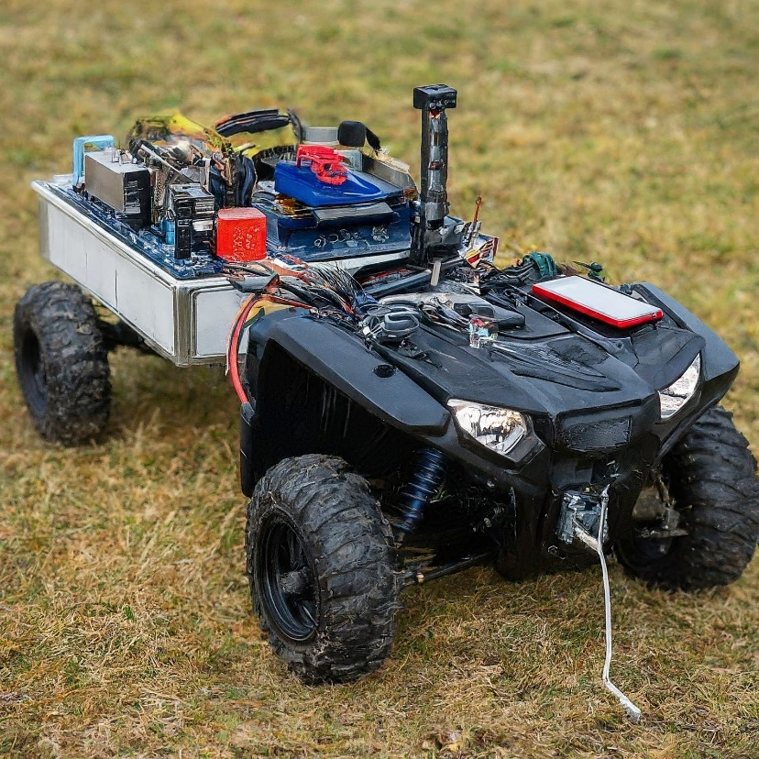
Arduino Uno: The Arduino Uno microcontroller board will be used to control the sensor and communicate the reports.
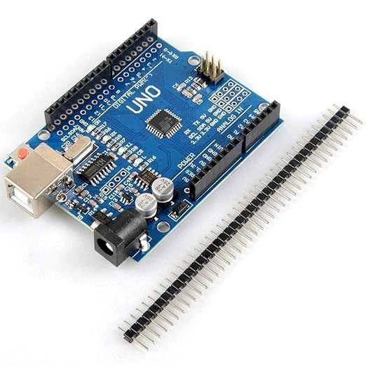
MQ2 Sensor: This sensor will be used to detect if there are any poisonous gases in the environment or not.
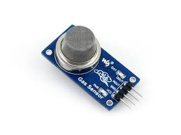
Buzzer : The speaker/buzzer will be used to sound an alarm if traces of any poisonous gas are detected.
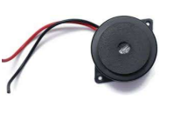
Breadboard: The breadboard will be used to connect the components together.
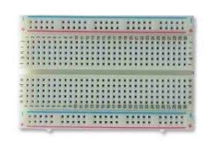
Rechargeable Battery: The battery will be used to power the system.
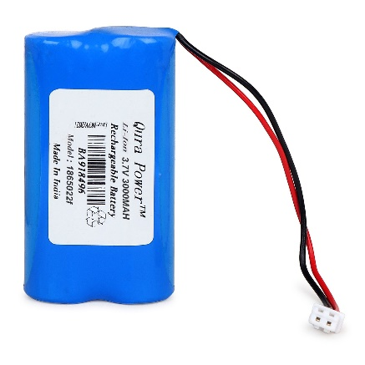
Jumper wires: Jumper wires will be used to connect the components together.
Trailer Setup: This will be used to carry the poisonous gas detection setup.

